

**ASSIGNMENT 1**

**NAME: Mahnoor**

**Roll No: 231450813**

**INSTRUCTOR: Saad bin Saleem**

Here are the screenshots step by step on how to use SQLMAPS to attack an online website and retrieve data from it.

* **Installing of SQLMAP**

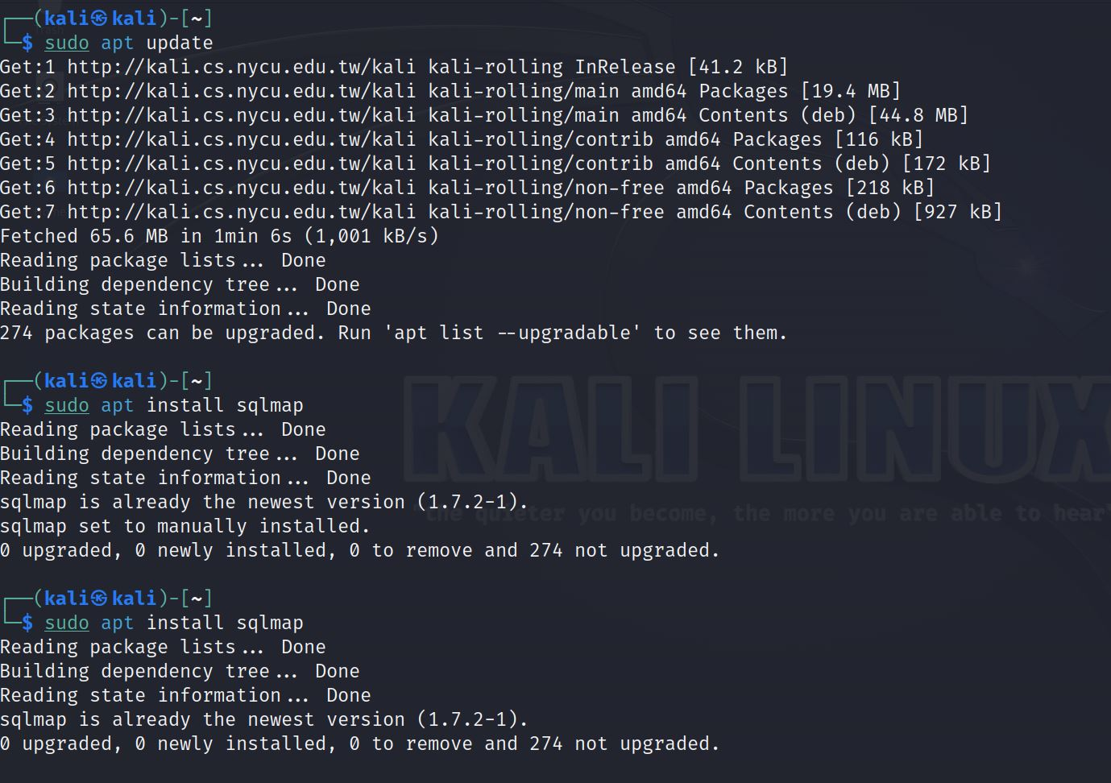

* **Open live website and take it’s URL**

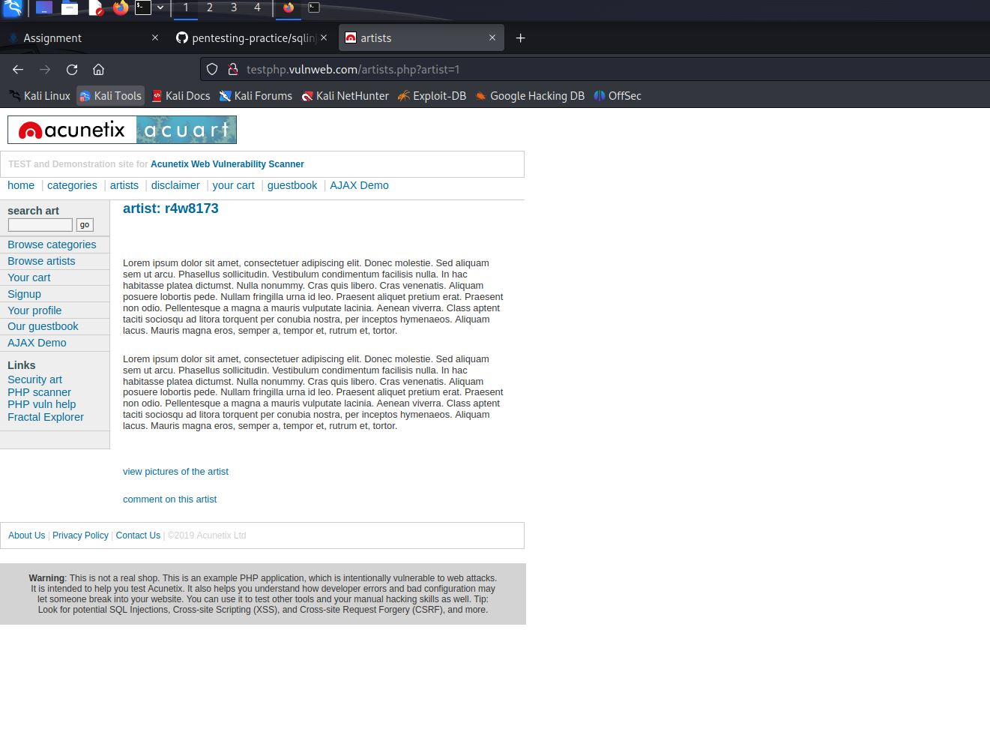

* **By using “ ‘ ” after the URL you can see that website is vulnerable.**

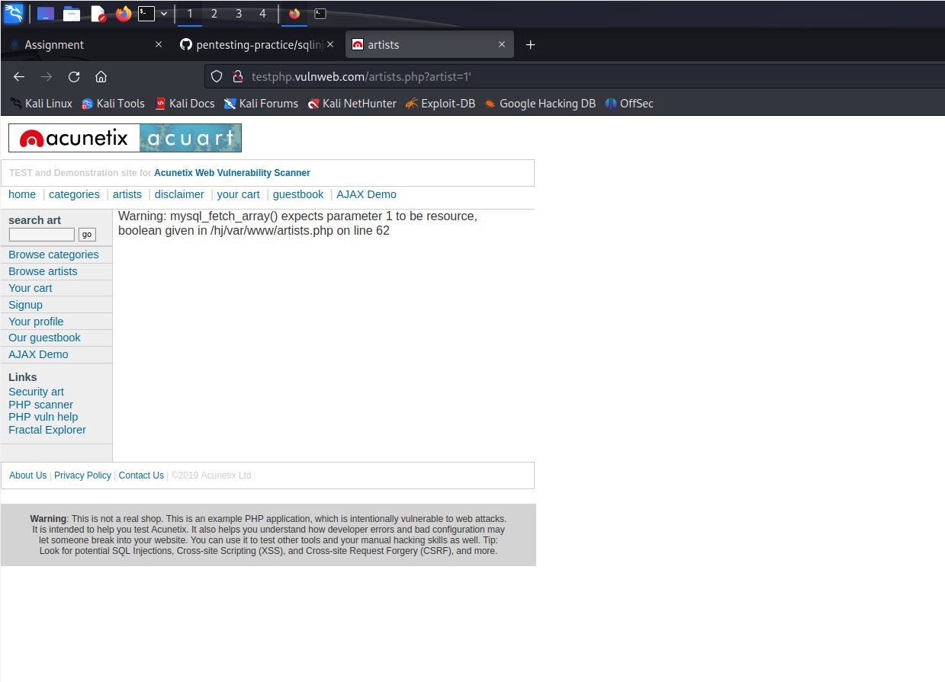

* **Go to terminal and write this SQL command to see website database**

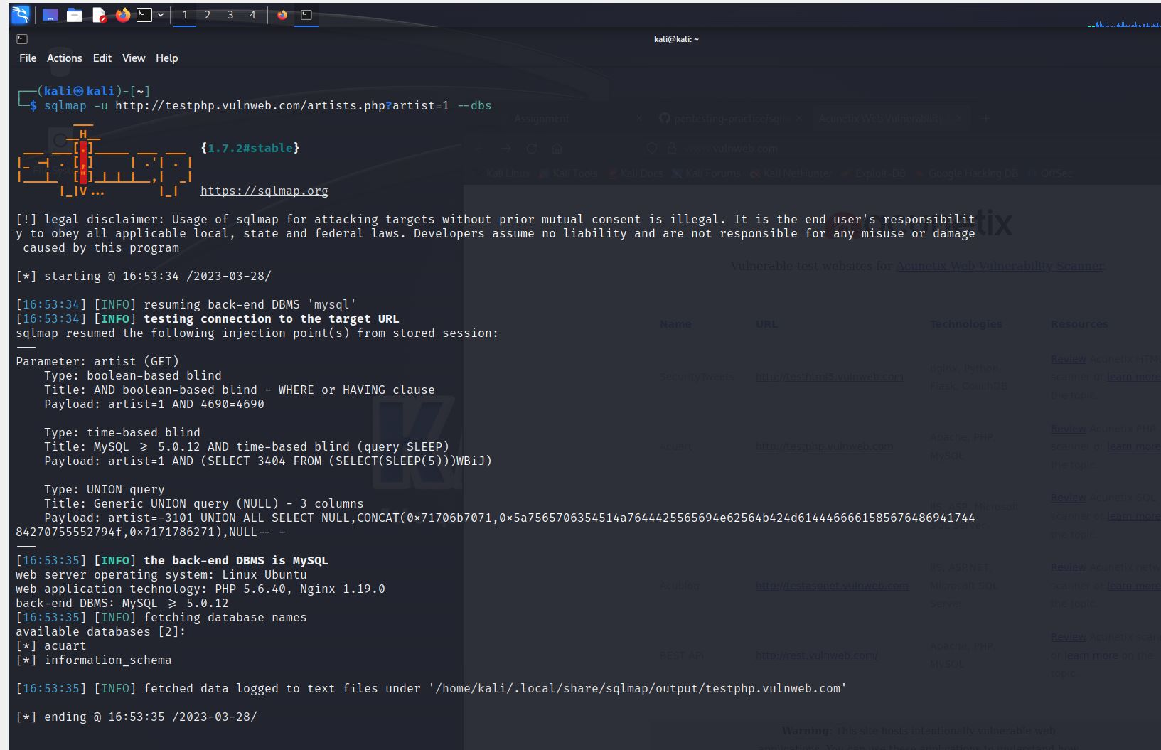

* **To see table names in the webserver we use command shown below**

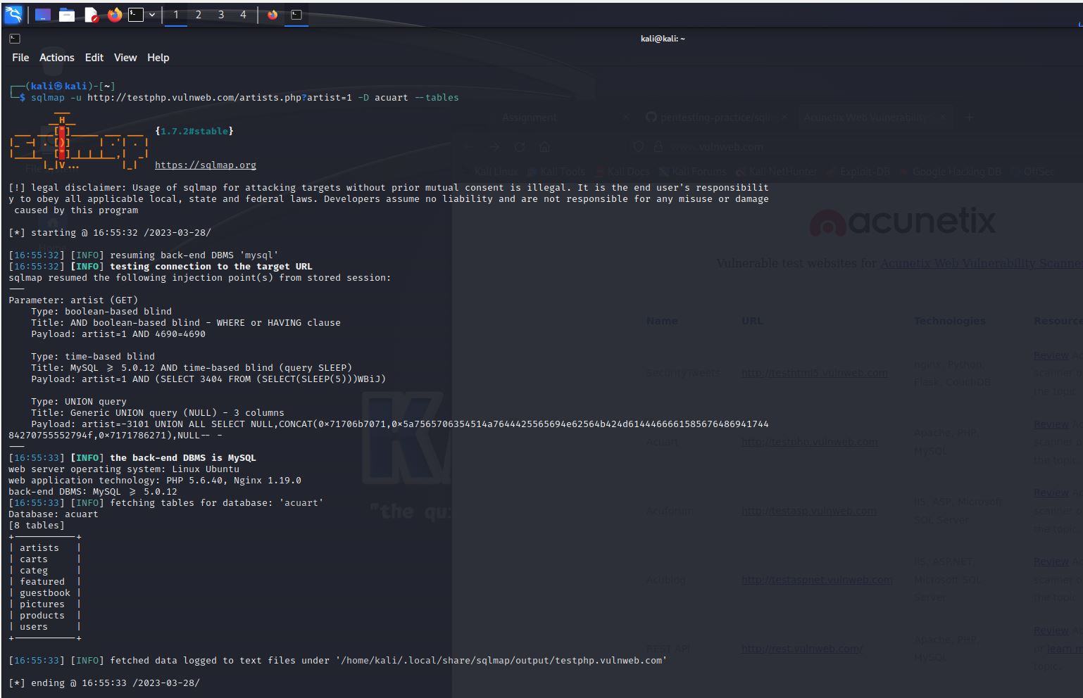

* **To look for username we use “T and uname “**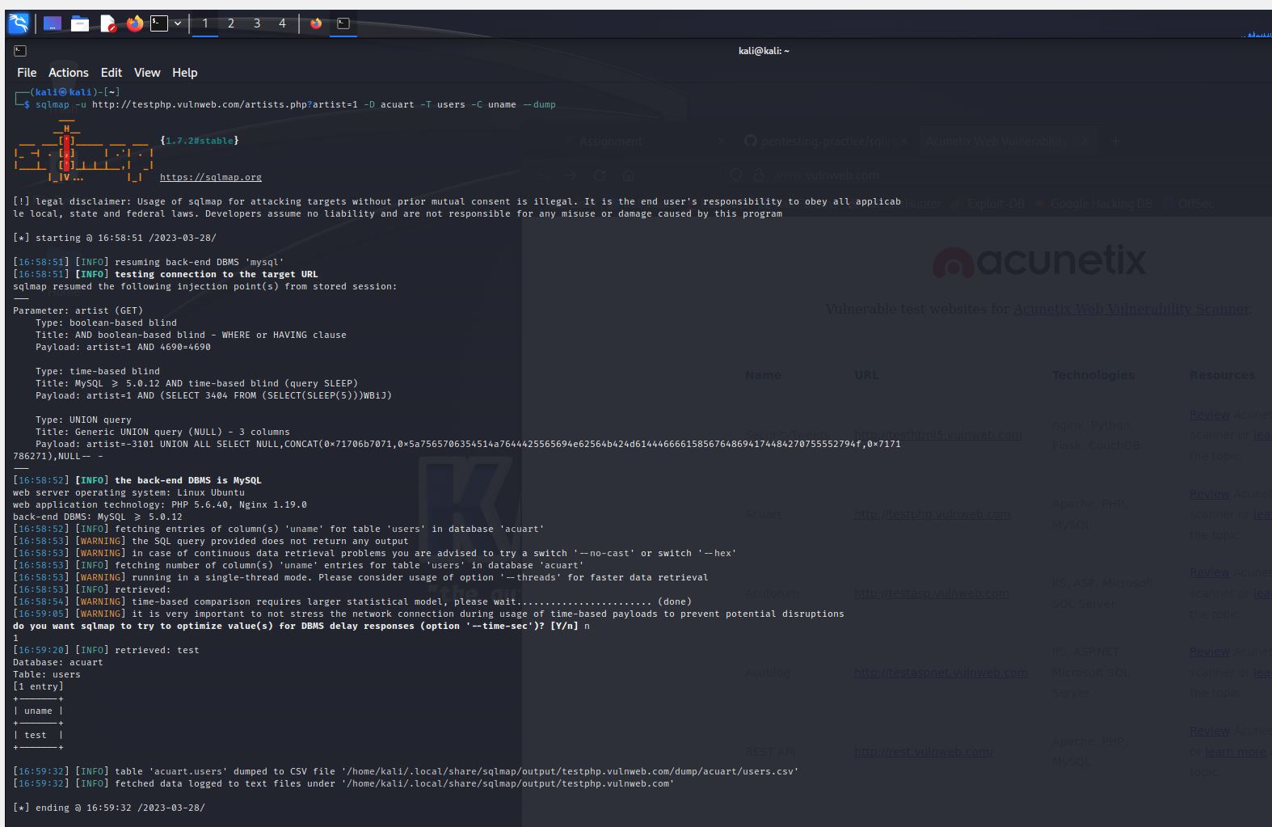
* **To retrieve the password from the webserver we use command shown below**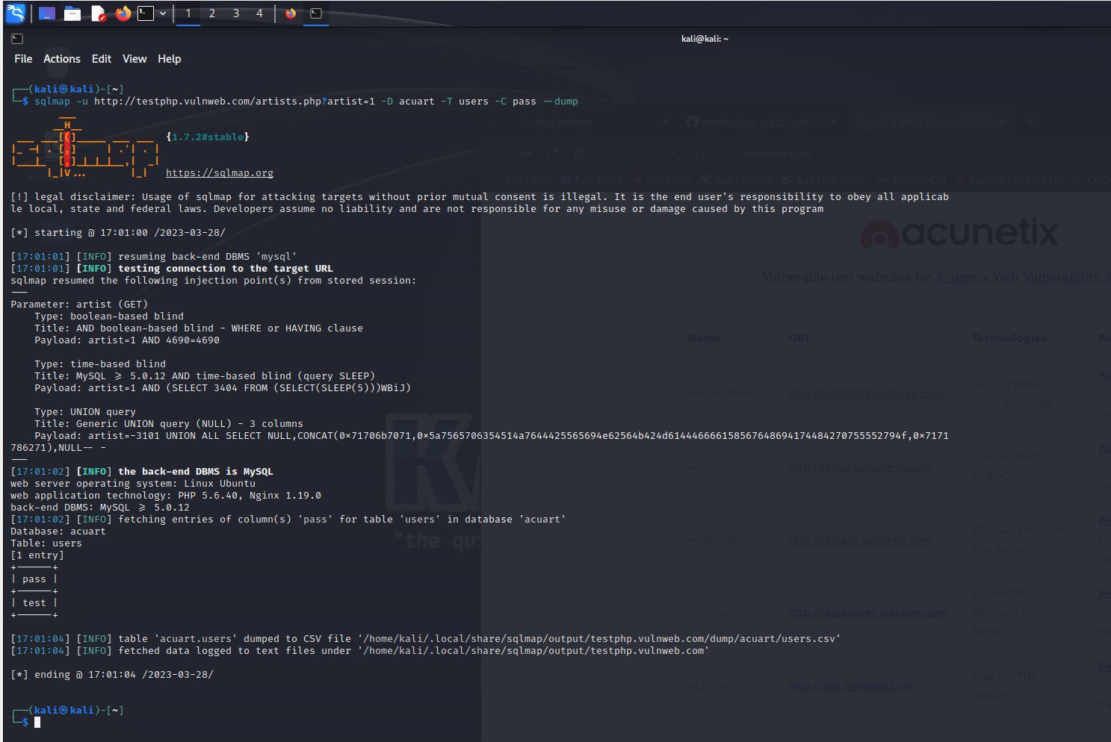
* **Testing the password and username that is retrieved from the SQLMAP**